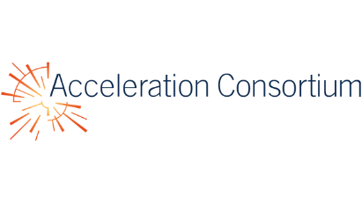
December 11, 2025
Dear Editor,

We are pleased to submit our manuscript entitled “Python-Controlled, Solvent-Resistant Fraction Collector for Automated Flow Synthesis” for consideration in Digital Discovery.
This work introduces a low-cost and fully solvent-resistant fraction collector that addresses a key limitation in continuous-flow chemistry: the lack of accessible hardware capable of accurate, reproducible, and automation-compatible sample isolation under both aqueous and harsh organic conditions. Such capability is essential for high-throughput experimentation, real-time reaction monitoring, and integration into self-driving laboratory workflows.
Our system integrates a benchtop CNC gantry, a chemically resistant selector valve, and a drop counter to provide real-time, volume-based sampling that remains stable across solvent types, viscosities, and flowrate fluctuations. The open-source control software enables programmable collection logic, coordination with upstream reactors, and straightforward customization for diverse laboratory setups. Experimentally, we demonstrate consistent droplet formation across a broad flowrate and viscosity range, high-fidelity separation with negligible cross-contamination, and robust operation in an organic synthesis setting validated by quantitative NMR. The system maintains performance without recalibration across solvents and flow conditions. Together, these findings establish a versatile and open-source platform that lowers the hardware barrier to high-throughput experimentation and supports the development of autonomous and closed-loop chemical workflows.
We believe this work will be of strong interest to the readers of Digital Discovery, particularly those working in laboratory automation, self-driving experiments, open-source instrumentation, and continuous-flow synthesis. We appreciate your consideration and look forward to the opportunity to have our manuscript reviewed.

Sincerely,
Hongchen Wang
Department of Materials Science and Engineering
University of Toronto
Email: hongchen.wang@mail.utoronto.ca

